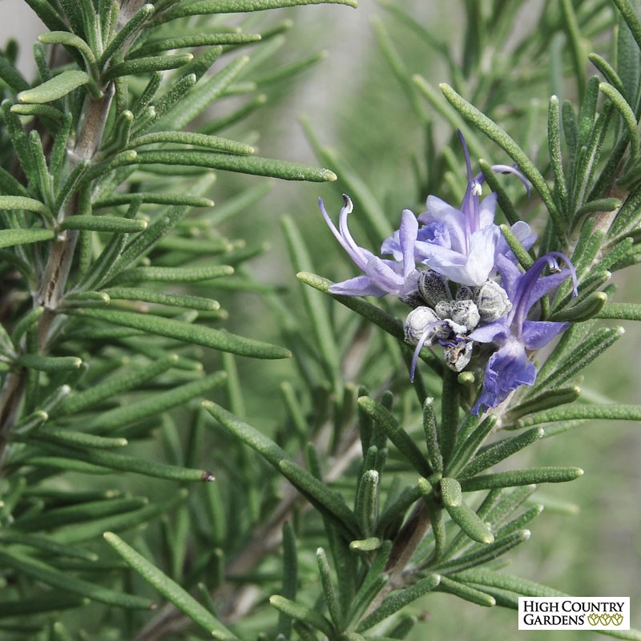

**Rosemary**

*Rosmarinus officinalis*

(<https://www.highcountrygardens.com/media/catalog/product/cache/3/image/cdd56dd0d7347dc27aa421c918b212c4/r/o/rosemary-hill-hardy-_2_.jpg>)

**Category:**

Herbs

Shrubs

Tropicals and Tender Perennials

**Bloom Characteristics:**

This plant is attractive to bees, butterflies and/or birds

Flowers are fragrant

**Water Requirements:**

Drought-tolerant; suitable for xeriscaping

**Height:**

4-6 ft. (1.2-1.8 m)

**Spacing:**

18-24 in. (45-60 cm)

**Hardiness:**

USDA Zone 7a: to -17.7 °C (0 °F)

USDA Zone 7b: to -14.9 °C (5 °F)

USDA Zone 8a: to -12.2 °C (10 °F)

USDA Zone 8b: to -9.4 °C (15 °F)

USDA Zone 9a: to -6.6 °C (20 °F)

USDA Zone 9b: to -3.8 °C (25 °F)

USDA Zone 10a: to -1.1 °C (30 °F)

USDA Zone 10b: to 1.7 °C (35 °F)

**Sun Exposure:**

Full Sun

**Danger:**

N/A

**Bloom Color:**

Pale Pink

Medium Blue

Dark Blue

White/Near White

**Bloom Time:**

Blooms repeatedly

**Foliage:**

Evergreen

Aromatic

**Soil pH requirements:**

6.6 to 7.5 (neutral)

7.6 to 7.8 (mildly alkaline)

7.9 to 8.5 (alkaline)

**Patent Information:**

Non-patented

**Propagation Methods:**

From softwood cuttings

From semi-hardwood cuttings

From hardwood heel cuttings

By simple layering

By stooling or mound layering

**Seed Collecting:**

Allow seedheads to dry on plants; remove and collect seeds